Jimma University
College of Health Sciences
School of pharmacy
Department of Pharmacognosy and Phytochemistry
Pharmacognosy Note for Pharmacy students by Tamirat T. (B.Pharm & MSc in Pharmacognosy)
1. Introduction to Pharmacognosy
1. 1. Definition, History and Scope of Pharmacognosy
1.1.1 Definition
The term Pharmacognosy comes from two Greek words: "pharmakon" meaning drug or medicine, and "gnosis" meaning knowledge. It means ‘knowledge or science of drugs’. It was first coined by J.A Schmidt in his hand-written manuscript to describe the study of medicinal plants and their properties, which was published in 1811. He was a physician in Austria, then professor at medico-surgical academy in Vienna, until his death.
Pharmacognosy is very broad science with applications in pharmacy and in many other fields of study. However, irrespective of its broadness previous descriptions restricted its definition to studies of medicinal plants originally focusing on their identification and some of their chemical constituents. In a broader perspective, more inclusive definition is required. Thus, broadly, Pharmacognosy is defined as the study of biologically active natural products. Pharmacognosy is connected to many other areas of science and a complete understanding of this field has to be taken into account, but not be limited to botany, chemistry, enzymology, genetics, pharmacology, toxicology, horticulture, quality control, and biotechnology.
American society of Pharmacognosy precisely defines pharmacognosy as "the study of the physical, chemical, biochemical and biological properties of drugs, drug substances or potential drugs or drug substances of natural origin as well as the search for new drugs from natural sources". In short, pharmacognosy is the study of drugs of natural origin.

Why is natural product study so important?

In the areas of cancer and infectious diseases, 60 and 75%, respectively, of new drugs, originate from natural sources (Gullo, 2006).
- Natural products are sources for innovation in drug discovery
- Serves as a tool to better understand targets and pathways in the disease process
- Help in understanding of cellular pathways that may contribute in drug discovery
- The process is environment friendly
- Natural products are more tolerated by the body
- The study of natural products can generate valuable information for the synthetic chemist
According to FDA (1997) drugs of natural origin: unmodified, semisynthetic from a natural source, or modeled on a natural product parent: constitute 40% (Gullo, 2006). They form the bases for many of the drugs currently in commercial use such as taxol, khellin, morphine, codeine, vincristine, digoxin, vinblastine, reserpine, physostigmine, atropine, quinine, quinidine, sennosides, ß-sitosterol, psoralens, vincamine, , artimesinine & as well as many others.
Example: Khellin is the Moorish name for Ammi visnaga, an herbaceous plant found in Egypt. It was used primarily as a folk remedy for renal colic. The compound khellin was isolated from the plant and people began to study its properties. In the early 20th century, researchers searched for khellin analogues with lower toxicities and better efficacy. A number of drugs were discovered in researching khellin analogues. Amiodarone and Cromolyn sodium are khellin analogues used in current medical practice.
1.1.2 Brief history of Pharmacognosy
One of the oldest human activities is the study of plants and animals, particularly as sources of food. Pharmacognosy itself is generally regarded as the oldest of the pharmaceutical sciences. Since prehistoric times, the pharmacognocist has been the person whose role in the society was to identify crude drug materials, to assure the absence of adulteration and to diagnose and dispense an appropriate regimen. From the earliest times, man had to distinguish between those plants which were poisonous and those which were not. Gradually, man developed a knowledge of naturally occurring drugs, which was transmitted at one time orally, later in written form as papyri, baked clay tables, parchments, manuscript herbals, printed herbals, pharmacopoeias and other works and most recently by computerized information retrieval systems.
History – Highlights
2500 BC – Sumerian use of opium poppy
1770 BC – Code of Hammurabi in Babylon – mentions plants
1550 BC – Ebers papyrus in Egypt – 700+ medicinal formulas
400 BC – Hippocrates (Greece) – “Father of Medicine”
300 BC – Theophrastus, Botanical Gardens in Athens
77 AD – Dioscorides, De Materia Medica
1500 AD – Age of herbalism, Paracelsus – Doctrine of Signatures
1775 AD – Dr. William Withering – Foxglove extracts
1900 AD – Half of drugs in U.S. Pharmacopeia still derived directly from plants
1900s – Advent of “scientific medicine”
1.1.3 Scope of Pharmacognosy
Drugs could be obtained from natural sources (plants, animals & minerals) or synthetically.
- Identification or authentication of crude drugs
- Develop protocol and/or implement processes involved in the collection, drying, and preservation of crude drug material
- Cultivation and collection of medicinal plants
- Evaluation of natural products for biological activities
- Isolation of natural products, structural activity study or use isolated or in silico models for synthesis
- Incorporation of a natural product in the system of modern medicine
- Investigation of biosynthetic pathways
- Develop plant tissue cultures
- Recombinant DNA technology or Genetically engineered drugs (fermentation)
- Microbial transformation
- Isolation and characterization of active secondary metabolites from natural sources
- Spectroscopic and molecular techniques application for natural product identification
- Legal and regulatory issues
1.2 Crude drugs
1.2.1 Definition and nomenclature of crude drugs
Crude drugs are unmodified natural preparations of plants, animals, fungi, bacteria or minerals or else its parts which after collection are subjected only to drying or making them suitable for preserving and packing. It can also be any products that have not been advanced in value or improved in condition by grinding, chipping, crushing, distilling, evaporating, extracting, artificial mixing with other process or treatment beyond what is essential to its proper packing and the prevention of decay or deterioration pending manufacture. The crude drugs of natural origin can be divided into two main categories as organized crude drugs and unorganized crude drugs.
Organized drugs consist of the cellular organization in the form of anatomical features. These are mostly the crude drugs from plant sources. Almost all of the morphological plant parts or the entire plant itself can be called organized drugs. A long list can be made of such crude drugs. Example, Cinchona bark, Sandalwood, Quassia wood, Senna, Digitalis leaves, Nux vomica seeds, Rauwolfia roots and many other examples of above-mentioned groups or crude drugs exemplified by some other morphological organs can be quoted as the example of organized crude drugs. Microscopical and anatomical studies are preeminent for such crude drugs. These can be used directly in medicine or can be used by modifying or by extracting the active ingredient from it.
The unorganized drugs do not have the morphological or anatomical organization as such. These are the products which come directly in the market but their ultimate source remains the plants, animals or minerals. Microscopical studies are not required for such crude drugs. These includes products like plant exudates as gums, oleogums, oleogum resins, plant lattices like that of opium, aloe juices or dried extracts of black and pale catechu, agar, alginic acid, etc., are products coming under this group. Other products like essential oils, fixed oils, fats and waxes obtained from vegetable or animal sources, although hydro-distilled or extracted from plant, become the direct commodity for use. Unorganized crude drugs may be miscellaneous mineral products like shilajit. These products may be solid, semisolid or liquid and the physical, chemical and analytical standards may be applied for testing their quality and purity.
In general, crude drugs can be entire organism (plant, animal), part of an organism (a leaf or flower of a plant, an isolated gland or other organ of an animal) or else an extract or an exudate of an organism may also be isolated pure compounds.

Examples of crude drugs:

I. Animal Drugs
- Animal drugs are produced from wild or domesticated animals.
Examples:

a. Entire animals
- Cantharides:
Cantharides are the dried beatles Lytta vesicatoria, Meloide.
Constituents: Cantharides contain cantharidin (inner anhydride of dibasic acid; cantharic acid).
Uses: Cantharides is an irritant rubefacient.
  - If taken internally it is excreted by kidney and irritates the urinary tract; this accounts for the popular reputation of the drug as an aphrodisiac.
  - Topical application of solution of cantharidine is said to be effective in the removal of warts.
  - Now it is only employed in veterinary medicine due to its toxicity.
- Cochineal or coccus:
It consists of the dried female insects, Dactylopius coccus cocidae (the generic name coccus means grain or berry refers to the appearance of the insect; cacti means prickly plant, the insect being cultivated on various species of cactus).
Constituents: Cochineal contains 9-10 % glycosidic colouring principle, carminic acid that is an anthraquinone derivative.
Uses: The principle use of cochineal is as colouring agent in toothpastes
b. Animal Products:
- Musk: Musk is the distilled secretion from the preputial follicles of the musk deer (male animal) Moschus moschiferous, Cevidae.
  - The distilled musk yields about 1.4% of dark brown volatile oil, the chief odorous constituent of which is muskone.
  - This small deer is found in China and Himalayas.
Uses: Musk acts as a fixative and is an important ingredient of many high-class perfumes.
- Thyroid: Thyroid is the cleaned, dried and powdered thyroid gland previously deprived of connective tissue and fat.
- It is obtained from domesticated animals that are used for food by man e.g. Ox, Bos tarus Boivdae.
Constituents: Thyroid contains 0.17 % - 0.23 % of iodine in thyroid combination.
- Now, quantities needed for commercial purposes are provided by chemical synthesis.
Uses: Thyroid is used in goiter and in obesity.
- Pepsin: Pepsin is the substance containing a proteolytic enzyme obtained from glandular layer of the fresh stomach of the hog Sus scrafa, Suidae.
- Pepsin is prepared by digesting the mined stomach lining with hydrochloric acid.
- This solution is clarified and carefully evaporated in vacuum.
Uses: Pepsin is used to assist gastric digestion.

II. VEGETABLE DRUGS
- The large majority of botanical drugs in current use are derived from leaves or aerial parts.
Nomenclature of crude drugs
  - Common, vernacular or local names
  - Scientific names are more appropriate for exchange of information and they avoid ambiguity.
Taxonomy:
- It is the science of naming organisms and their correct integration into the existing system of nomenclature
- The names of species are given in binomial form: the first part of the name indicates the wider taxonomic group, the genus; the second part of the name is the species.
- Scientific name is written in italics or is underlined in texts.
Papaver somniferum L.
Species: somniferum, here meaning ‘sleep-producing’
Genus: Papaver (a group of species, in these case poppies, which are closely related)
Family: Papaveraceae (a group of genera sharing certain traits)
L.: indicates the botanist who provided the first scientific description of the species and who assigned the botanical name
Examples:
Scientific name Common name
Dioscorea sativa cultivated yam
Dioscorea villosa wild yam
Coffea abyssinica bunna, coffee

A list of commonly employed Latin adjectives as species name of plants
aabyssinica = from Abysinnia (Northern Ethiopia) (East Africa)  acaulis = stemless  aestivalis = flowering in spring  alba = white  alpestris = from mountains  alpicola = from mountains  alpina = from the alps  altissima = tallest  america = from America  angustifolia = narrow-leaved  annua = annual  antha = -flowered (e.g. micrantha = small-flowered)  arboricola = living on trees  arctica = from the arctic  arenaria = from sandy places  argentea = silvery  armata = prickly  arvensis = of the field  aurantiaca = orange  aurea = golden, yellow  australis = from the south (not necessarily Australia)  autumnalis = of autumn  azurea = blue  barbata = bearded, hairy  bellidifolia = with leaves like those of a daisy  borealis = from the north  bulbifera = bearing bulbs  bulgarica = from Bulgaria  caerulea = blue  caespitosa = dense  campanulata = campanulate, like a bell  campestris = of the field  canadensis = from Canada  canariensis = from the Canary Isles  capensis = from the Cape, South Africa  chilensis = from Chile  chinensis = from China  chrysantha = yellow  clivora = from the hills  coccinea = red  compacta = compact  decidua = deciduous  densiflora = dense-flowered  digitata = (leaves) like a hand, with five lobes  edulis = edible  esculenta = edible  farinosa = floury, powdery  ficifolia = like a fig leaf  flava = yellow  -flora = -flowered (e.g. viridiflora = green-flowered)  flore plena = with double flowers  florida = floriferous  foetida = with an unpleasant smell  -folia = -leaved (e.g. tenuifolia = narrow-leaved)  foliosa = leafy  fruticosa = shrubby  gigantea = giant  glabra = smooth  glacialis = from cold areas  glutinosa = sticky  graeca = from Greece  graminifolia = with grassy leaves  grandiflora = large-flowered  grandis = big  helvetica = from Switzerland  hirsuta = hairy  hispida = bristly  humilis = short  hyemalis = of winter  incana = grey  inodora = unscented  integrifolia = entire, undivided (leaves)  japonica = from Japan  lanata = woolly  lanceolata = lance-shaped (leaves)  latifolia = wide-leaved  longiflora = with long flowers  longifolia = with long leaves  lutea = yellow  macrantha = large flowered  macro- = large- (e.g. macrorhiza = large-rooted)  macrocarpa = large-fruited  macrophylla = with large leaves | macrorrhiza = with large roots  maculata = spotted  magellanica = from the south of South America  magenta = magenta  magna = big  majus = bigger  maritima = maritime, near the sea  maxima = biggest  mexicana = from Mexico  micrantha = small flowered  microphylla = with small leaves  millefolia = with many (thousands of) leaves  minima = small  minor = smaller  montana = from mountains  multiflora = many flowered  muralis = growing on walls  nana = small  nocturna = nocturnal  ochroleuca = cream  odorata = perfumed  officinalis = with herbal uses  ovalifolia = with oval leaves  pallida = cream  palustris = from marshes  parvi- = small- (e.g. parivflora = small-flowered)  parviflora = small flowered  parvifolia = with small leaves  pauci- = few- (e.g. pauciflora =few-flowered)  pauciflora = few-flowered  paucifolia = with few leaves  pendula = hanging  perennis = perennial  phoenicea = purple  -phylla = -leaved (e.g. macrophylla = large-leaved)  pinnata = with pinnate leaves  poly- = many (e.g polyantha = many-flowered)  polyphylla = with many leaves, leafy  praecox = early, of spring  pratensis = field  procumbens = creeping  prostrata = prostrate  pulverulenta = dusty  pumila = small  punica = red  purpurea = deep pink  pygmaea = small  quercifolia = oak=leaved  rediviva = perennial  rivalis = from near rivers  rivularis = from near rivers  rosea = rose pink  rotundifolia = round-leaved  rubra = red  rupestris = of hills  rupicola = of hills  russica = from Russia  sanguinea = blood-red  sativa = cultivated  saxatilis = of rocks  scaber = climbing  scandens = climbing  semperviva = perennial  sibirica = from Siberia  sinense = from China  somnifera = inducing sleep  spicata = spiked  spinosa = spiny  stellata = starry  sulphurea = yellow  sylvestris = of woods  tenuifolia = with thin, narrow leaves  texensis = from Texas  tomentosa = tomentose, woolly  trifoliata = trifoliate, with three-lobed leaves  umbellata = unbellate, with flowers in an umbel  velutina = velvety  vernalis = of spring  villosa = hairy  violacea = violet  viridis = green  viscosa = sticky  vitifolia = with leaves like a vine  volubilis = twining  vulgaris = common

Origin of crude drugs
1. The natural or biological origin:
The natural origin of a drug is the plant or animal that yields it.

The biological origin of a plant is called botanical origin.
- The biological origin of animal is called zoological origin.
Knowledge of the biological origin enables one to indicate the proper right material and the precise article one which to obtain. E.g. Strophanthus is used as heart tonic and includes about 30 species all from the same district in the Central Africa. One year the drug is active, even poisonous and in other cases it is inactive. This is due to the fact that the drug is gathered from any species, which collectors may find. If the drug is obtained from one and the same species, the supply of the drug will be always of the same potency.
The identification of the exact origin of the drug needs:
- Comparison with authentic or genuine sample or
- Identification by comparing the published description of the drug with the representative unknown sample

2. Geographical Sources
The geographical source or habitat is the region in which the plant or animal yielding the drug grows. Knowledge of the geographical source also assists in the identification of the biological origin. Every climatic region of the earth is the native habitat of some species of animals and plants.
Plants grow in their native countries are said to be indigenous to this regions e.g. Hyoscyamus muticus (Egypt), Cannabis sativa (India).
  - Cannabis sativa if grown in India is about 1 meter in height produced weak bast fibers and much resin, but when grown in Italy, it is of different characters producing a large tree with strong bast fibers no resin and the fibers are of economic value.
  - Datura sauveolens growing in Brazil contain mainly hyoscyamine and traces of hyoscine. When introduced to Egypt it was found to contain hyoscine and traces of hyoscyamine and metelodine.
Plants are said to be neutralized when they grow in a foreign land or in a locality other than their native homes.
E.g. Cotton is naturalized in Egypt and indigenous to America.
3. Commercial Origin:
Commercial origin of drug refers to its production and its channels of trade E.g.
- Canton Rhubarb is the product of the plants growing in various parts of China but shipped by the way of Canton.
2. Alexandrian senna is the product growing in Khartom but it was shipped by the way of Alexandria.
  - Commercial origin may be changed in the course of time e.g. Spanish liquorice, which was originally produced in Spain but now produced elsewhere.
1.2.2 Classification of crude drugs
- Alphabetic: The drugs are arranged in alphabetical order, using either Latin/vernacular names
Advantage: quick reference
Disadvantage: no indication of the interrelationships between plants (drugs)
Used in
  - Dictionaries
  - Pharmacopoeias
- Taxonomic: The drugs are arranged according to the plants from which they are obtained in phyla, families, genera and species, using one of the accepted systems of the botanical classification.
Advantage: Precise & ordered arrangement (no ambiguity)
Disadvantage: Botanical knowledge decreases over the years in students
popular with teaching
- Morphological: The drugs are divided into groups from such as the following: leaves, flowers, fruits, seeds, herbs and entire organisms, woods, barks, rhizomes and roots (known as organized drugs) and dried lattices, extracts, gums, resins, oils, fats and waxes (unorganized drugs).
Advantage: Practical application to the study of plant drugs
Disadvantage: Microscopical studies are needed to identify powdered herbs

Morphology of higher plants:
1. Flower
- It is the essential reproductive organ of a plant.
- For an inexperienced observer, two characteristics of a flower are particularly noteworthy: the size and the color
- Although the flowers are of great botanical importance, they are only a minor source of drugs used in phytotherapy or pharmacy e.g. chamomile, Matricaria recutita L. (Asteraceae )
2. Fruit and seed
- The lower plants, such as algae, mosses and ferns, do not produce seeds
Gymnosperm and Angiosperm
- Gymnosperm: they are characterized by seeds that are not covered by a secondary outer protective layer, but only by the testa – the seed’s outer layer
- Angiosperm: the seeds are covered with a specialized organ (the carpels) which in turn develop into the pericarp.
- Drugs from the fruit thus have to be derived from an angiosperm species
- Fruits and seeds have yielded important phytotherapeutic products, including:
Fruit: Caraway, Carum carvi L. (Umbelliferae)
Seed: (white) mustard, Sinapis alba L. (Brassicaceae)
3. Leaves
- The function of the leaves, as collectors of the sun’s energy and its assimilation, results in their typical general anatomy with a petiole (stem) and a lamina (blade)
- A key characteristic of a species is the way in which the leaves are arranged on the stem, they may be:
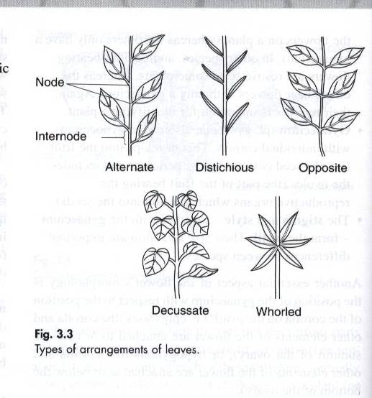

The form and size of leaves are essential characteristics e.g. oval, oblong, obovate, rounded, linear, lanceolate, elliptic, spatulate, cordate, hastate or tendril

The margin of the leaf is another characteristic feature e.g. entire, serrate, dentate, sinuate, ciliate or spinose

Numerous drugs contain leaf material as the main component.e.g. Deadly nightshade, Atropa belladonna L. (Solanaceae)
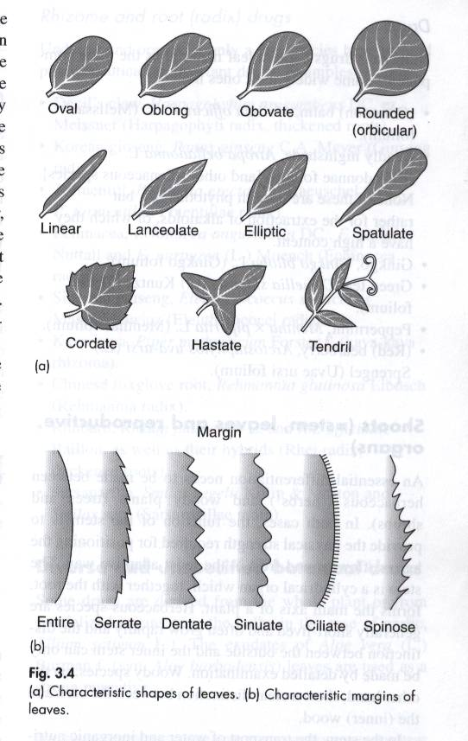

4. Bark

The bark as an outer protective layer frequently accumulates biologically active substances e.g. Red cinchona, Cinchona succirubra L. (Rubiaceae)

No stem-derived drug is currently of major importance

5. Rhizome and root drugs

Underground organs of only a few species have yielded pharmaceutically important drugs e.g. Sarsaparilla, Smilax regelii (Smilacaceae) and Korean ginseng, Panax ginseng (Araliaceae)

6. The bulbs and exudates

Garlic, Allium sativum L. (Liliaceae) and Aloe vera L. (Asphodelaceae)
4. Pharmacological or therapeutic: Plant drugs are grouped according to their pharmacological action of the most important active constituent in the plant or according to the drug’s therapeutic use. Disadvantage: The constituents of one drug may have more than one therapeutic action (fall into numerous groups. E.g. Flavonoids)
5. Biogenic/Chemical Classification: The drugs are divided into groups according to their active constituent. E.g. Carbohydrates, Glycosides, Lipids, Volatile oils, Steroids…or based on the biosynthetic pathways of the main active constituent.
1.2.3 The evaluation of crude drugs
It deals with the correct identification of the plant, determination of the quality & purity & detection of nature of adulteration of the crude drugs.
Reasons for crude drug evaluation:
- biochemical variation in the drug
- deterioration due to treatment & storage
- substitution and adulteration
Identification of the plant
- The identity of a drug can be established by:
  - Actual collection of the drug from the plant or animal that has been previously identified
Research investigators must be absolutely certain of the origin of their samples; hence, institutions engaged in pharmacognostic research frequently establish “drug gardens”.
- Another method of identification is by comparing a representative unknown sample with a published description of the drug with authentic drug samples.
  - A high grade of quality in a drug is of primary importance and efforts should be exerted to obtain and maintain this high quality.
The most important means of accomplishing this are:
- Collection of the plant from the correct natural source at the proper time
- Preparation of the collected drug by proper cleaning, drying and garbling
- Proper preservation of the cleaned, dried, pure drug against contamination with dirt, moisture, fungi, filth and insects.
- The evaluation of the drug involves a number of methods, which may be classified as follows:

Organoleptic (Morphological) Evaluation
Organoleptic is the effect produced by the organs which refers to evaluation by means of the organs of sense and includes the macroscopic appearance of the drug, its odor and taste and the feel of the drug to the touch.
For convenience of description the macroscopic characteristic of a drug may be divided into four headings:
  - Shape and size.
  - Color and external markings
  - Fracture and internal color.
  - Odor and taste.
- Microscopic Evaluation
The microscope is not only essential for the study of the adulterants in powdered plant and animal drugs but is indispensable in the identification of the pure powdered drug. Those sections of the official monograph headed histology and powder deal almost exclusively with the microscopic appearance of the drug in sectional view and powdered form. Not only is the microscope useful in the study of the histologic elements of the drugs and in the detection of adulterants from the histologic standpoint, but it can be used for a quantitative microanalysis of admixed or adulterated powders.
Few important staining reagents:
- Phloroglucinol and hydrochloric acid for lignified tissues.
- Chlor-zinc iodide reagent for cellulosic tissues.
- Tincture of alkanol for subrised or cuticularized walls.
- Ruthenium red for gums and mucilage containing cells.
Another important aspect of microscopical evaluation is the study of surface constants. The leaf constants like stomatal number, stomatal index, palisade ratio, vein islet and vein termination number are studied by using camera lucida. These constants are used for the detection of their adulteration.
- Chemical Evaluation
It comprises of different chemical test & chemical assays. The isolation, purification & identification of active constituents are chemical methods of evaluation. Preliminary phytochemical screening is a part of chemical evaluation for establishing chemical profile of drug.
Tables for chemical examination (Plant constituents, Tests & Reagents)
- Alkaloids
- Dragendroff`s reagent
- Hager’s reagent
- Wagner’s reagent
- Mayer’s reagent
- Carbohydrates
- Molisch`S Test, Fehling test, Benedict’s test, Barfoed`s test, Bial`s test, Aniline acetate test, Phloroglucinol, Seliwinoff`s test, Tollen`s test, Cobalt chloride test, Iodine test, Tannic acid tests
- Glycosides
i) Anthraquinone glycoside
- Micro sublimation test
- Borntrager`s test
- Modified borntrager`s test
ii) Cardiac glycoside
(a) Cardenolide :
1) Baljet`s test
2) Legal`s test
(b) Bufedanolide:
1) Liebermann’s test
(c) Deoxy sugars
iii) Cyanogenetic glycoside
  - Grignard`s test
iv) Saponins glycoside
  - Foam test
  - Heamolytic test
  - Liebermann’s test
v) Flavonoids glycoside
  - Shinoda test
  - Lead acetate test
vi) Coumarin glycoside
  - Fluorescence test
- Phytosterols
  - Liebermann Burchard`s test
  - Liebermann’s test
- Fixed Oils & Fats
  - Spot Test
  - Saponification test
- Phenolic compound & tannins
  - Ferric chloride test
  - Gelatin solution
  - Lead acetate solution
  - Aqueous bromine solution

Proteins & amino acid
  - Millon`s test
  - Biuret test
  - Ninhydrin test
8. Gums & Mucilage
- Alcoholic precipitation
- Molisch`s test
9. Volatile oil
  - The presence of essential oil can be detected by hydro distillation method.

Physical evaluation
In crude plant evaluation, physical methods are often used to determine the solubility, specific gravity, optical rotation, viscosity, refractive index, melting point, water content, degree of fiber elasticity, and other physical characteristics of the herb material.

Biological Evaluation (Bioassay)
Biological evaluation includes the quantitative assay of drugs using biological models of intact animals, animal preparations, isolated living tissues or microorganisms. The drugs, which cannot be assayed satisfactorily by chemical or physical means, are evaluated by biological methods. It is less precise, time consuming & more expensive to conduct
Generally used if: -
- The chemical identity of the active principle is not fully elucidated
- If no adequate chemical assay has been derived for the active principle as in case of insulin
- If the chemical assay is not a valid indication of biological activity
- If the drug is composed of complex mixture and activity. E.g. Digitalis,
- If purification of the crude drug is not possible E.g. Separation of vitamin D from irradiated oils
- It measures the actual biological activity of a given sample
The disadvantages are: -
- Quantitative accuracy is usually less than observed with most chemical analysis
- Techniques & interpretations involved vary with different operators
- The effect measured in the test animals is different from that observed in treating patients.
In-Vitro Bioassays
In-Vitro bioassays are rapid, less selective, but diagnostic, less expensive, suitable for minute amounts of materials, suitable for screening large number of samples in drug discovery programs.
In-Vivo Bioassays
In-Vivo bioassays are more selective, expensive, mostly Time Consuming, Animal model, requires large amounts of material, and hardly could guide the fractionation of extracts or mixture of compounds.
1.2.4 Types of preparations from plants
Crude drugs are used infrequently as therapeutic agents; more often their chief principles are separated by various means and are employed in a more specific manner. These principles are known as derivatives or extractives. Regardless of whether the derivative or extractive is a single substance or a mixture of substances, it is considered as the chief constituent of the drug.
- Fresh plant
- Crude drugs
  - Crude drugs are the correct part(s) of medicinal plants that have passed through the processes of collection and drying. Possibly, they may be grinded or shredded.
- Crude extracts (extractives)
  - Crude drugs may be boiled with water or oil.
  - Crude drugs may be extracted with other appropriate solvents.
  - Simple formulations (usually liquid) could also be prepared from crude extracts.
- Fractions
  - Solvent fractions could be prepared from crude extracts based on solubility
E.g.: methanol, acetone, butanol fraction etc.
  - Fractions could also be prepared on the basis of class of natural products.
E.g.: flavonoidal, alkaloidal, saponin fraction etc.
- Isolated pure compound
  - Single pure compounds that are responsible for the medicinal properties of a plant could also be isolated and then formulated in conventional dosage forms.
Reserpine is isolated from Raulfia serpentina and formulated as tablets for hypertension.
Ephedrine is isolated from Ephedra spp. and formulated as tablets, injection or powder for injection for asthma and chronic bronchitis
Note: The decision at which stage to make the drug available to consumers depends on:
- safety factors
    - Generally safety increases as we go from fresh plant material to isolation of pure compounds
- efficacy factors
    - Generally efficacy increases as we go from fresh plant material to isolation of pure compounds
    - However, in many cases isolated compounds may not be as effective as extractives because of perhaps additive or synergistic effects
- quality
    - Quality increases as we go from fresh plant material to isolation of pure compounds.
- Economic factors
    - Production cost increases as we go from fresh plant material to isolation of pure compounds
- To determine at which stage to use a medicinal plant as therapeutic agent, thorough study must be conducted on its constituents
- In order to study plant constituents they must be extracted from the plant first.
1.2.5 Scheme for Pharmacognostic studies of a crude drug
A systemic study of a crude drug involves:
- Official title, synonyms or vernacular names, if any
- Biological source and family
- Geographical Source or habitat
- History and introduction of crude drug
- Cultivation, collection, processing for market and commerce in crude drugs.
- Morphological or Macroscopical character
- Microscopic or histological studies
- Chemical constituents and qualitative chemical tests
- Pharmacological actions, therapeutic and other pharmaceutical uses and Pharmaceutical preparation or formulations
- Commercial varieties, substitutes and adulterants

1.2.6 Official and unofficial drugs
Pharmacopoeias: Pharmacopoeia is book recognized by the government as the legal authority for standardization of drugs. An official drug is one that is listed and described as being a definite therapeutic agent in the Pharmacopoeia. In the monograph of a crude drug the following information are generally covered: English, Arabic, Latin, French names, definition, description, special condition for collection or preparation for the market, identity tests, tests for adulterant, method of assay, special storage requirements and the usual dose and range of dosage if the drug is administered internally

  - Steps in the scientific analysis of drugs from natural resources

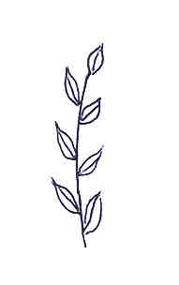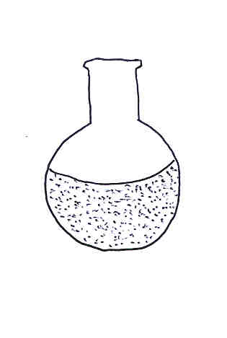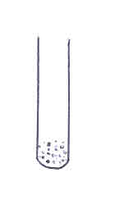
Plant
Crude Extract
Pure Compound
Molecular Structure
=
1.3.1 Selection and collection of plant material
- Accidental experience
- Doctrine of signatures
  - The notion that nature has put a clue (signature) for the medicinal value of plant that is the association of certain features of a plant with a certain disease
  - Probably first recognized in ancient China but formally articulated by Paracelsus (1493-1524) and further popularized by the writings of Jakob Böhme (1575-1624), that God had marked everything he had created with a sign which was intended as a clear indicator of the item's true purpose.
Examples:
- Plantago lanceolata has elongated leaves that look like a foot and so was used by caravan merchants for sore foot and foot wounds.
- Hepatica acutiloba (liverwort), has a three-lobed leaf that supposedly bears a resemblance to the liver. Because of this, herbalist believed the plant to be effective in treating liver ailments.
- Raulfia serpentina has roots that looks like snake (serpent) and was used for sneak bite.
- Random screening
  - Fruitful
  - Expensive
- Traditional use
  - Less expensive and more efficient
  - Ethnobotanical selection of medicinal plants
  - Recommended by WHO
- Literature Information Selection Technique (L.I.S.T.)
  - It correlates biological activity, botanical facts, and chemotaxonomic information

    - Taxonomic identification of the plant
  - This is the establishment of the exact identity of the plant (kingdom, subkingdom, division, class, order family, genus, species, variety)
  - Experienced field botanist is usually required.
  - Specimens collected from the field should be further compared with authenticated samples in Herbariums
  - Sample of the collected plant material should be stored in Herbariums for further reference
  - A card with details of the geographical distribution, altitude & habitat should be attached to the identified plant.
  - Helps to avoid mistakes over plant identity & for further reference
    - Literature survey on the identified plant
- This helps to avoid repetition and get update on current knowledge about the plant.
- It also helps to check consistency of folkloric use
    - Design of appropriate extraction method and separation methods
    - Checking extracts/ fractions for pharmacological activity
    - Identification of classes of compounds found in the plant (phytochemical screening)
    - Isolation of active compounds or fractions responsible for the pharmacological activity of the plant
Approaches to screening process
“The Bioassay-guided fractionation” versus “the Phytochemical approach”
Phytochemical Approach:
Requires firstly the isolation of a pure compound from the plant, and then to determine its bioactivity (if any) by applying the classic pharmacological studies.
It involves:
- Screening of extracts for specific chemical class.
- Using chemical reagents for detection.
- Chemically-guided fractionation.
Results:
- Minute/Trace components are mostly missed (detection limits).
- Unknown natural compounds are certainly missed.
- Mostly: No biological activity found
Bioactivity approach
- The state of the art of natural product-drug discovery
It involves:
- Extracts are screened for a specific therapeutic activity using mostly in-vitro bioassay(s).
- Only those possessing a bioactivity are fractionated
- Active fractions are further fractionated to isolate the active compounds in pure form
- Followed by characterization of its structure
Results: Often leads to the finding of highly potent, minor, novel compounds

- General methods in studying constituents of crude drugs
2. 1. Extraction
2.1.1 Definition: extraction is the process of obtaining the medicinally important components of a plant or a crude drug. More generally, extraction is the process of obtaining the extractable components of plants.
2.1.2 Preparation of plant material for solvent extraction
- Plant material is collected and the plant material is separated from unwanted materials such as unwanted parts of the plant, other plants, soil etc. (garbling).
- In most cases, the plant material is then dried but sometimes the fresh plant material is extracted
Drying:
  - Drying facilitates extraction
    - The plant material will easily be pulverized
    - The solvent easily penetrates into the plant material because there is no water
- If water is found in the plant material, an emulsion will be formed which will be difficult to break and decrease yield of extraction
- Drying inactivates enzymes
- A dried material is easy to store and transport
- Drying decreases deterioration and infestation
- Note that drying should be done as quickly as possible
- Drying conditions: Temperature not more than 40ºC and under the shade (avoid direct sunlight). UV radiation may produce chemical reactions giving rise to compound artifacts.
Methods:
Drying is carried out either by natural or artificial methods.
- Natural drying: this is accomplished by natural air in sun or shade.
- Artificial drying: this is a rapid method done at well-controlled temperature and is accomplished by:
- Drying chambers:
  - this method provides a controlled process. Drying chambers consist of closed space with several movable screen trays, arranged so as to allow the circulation of heated air. Its temperature and ventilation can be regulated to suit drying of different organs.
- Lyophilization (Freeze drying)
- Chemical drying using desiccators
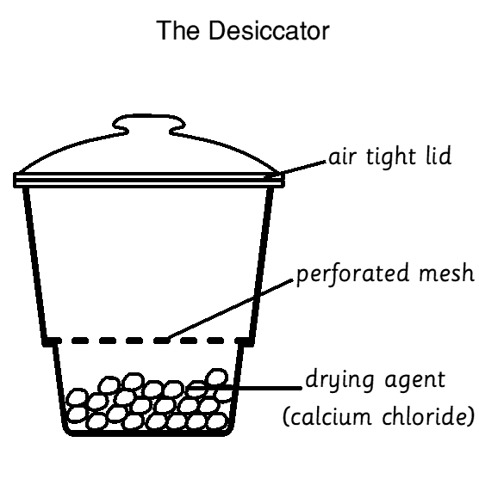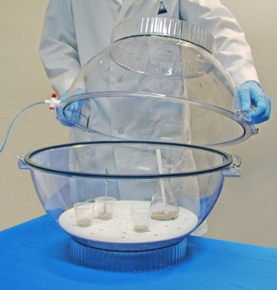

Fresh plant material is sometimes specifically required for study, and in this case it should be immediately extracted to prevent enzymatic processes or reactions that start after collection. That is to say some changes are favorable and hence conditions should be made suitable to encourage such changes. On the other hand certain changes are undesirable and conditions should be controlled to guard against their occurrence. Some drugs containing sensitive constituents as cardiac glycosides may undergo certain degrees of hydrolysis during drying. Fresh Vanilla pods contain gluco-vanillin and gluco-vanillic alcohol. On drying, hydrolysis of both glycosides and oxidation to vanillin take place.
General Drying Techniques
Leaves/Herbs:
  - 40-50º C
  - Maintains good color
  - Without over drying herbs
  - Normally destalked first
  - Best dried for short periods of time only prevents shriveling and discoloration
  - Leaves may be bleached through the drying process best dried in dark
Roots/Rhizomes
- Washed
- Sliced
- Dried between 30-65ºC
- Temperature too high: forms a tough crust on the outside preventing the further drying of deeper tissue
- Thick organs may require long periods of drying (10days-3weeks) to avoid mold growth
Flowers
- Normally destalked before drying
- Flowers may also be bleached when dried best dried in dark.
Volatile oil containing herbs
- Air-dried at very low temperature
- Avoid volatilization of oil contents
- Should also be dried separately from other herbs.
Fruits & Seeds
- Normally partially dry before harvesting
- May be air-dried afterwards
- Seeds are normally separated from the fruits before drying
- Fruits are normally left whole
- Some fruits (cardamom) rupture due to excessive heat.
Bark
- Occasionally requires the removal of the outer layers
- The plant material is ground to appropriate size
  - Grinding facilitates extraction by increasing surface area .i.e. the grinding process assists the penetration of the solvent to the cellular structure of the plant tissues there by increases the % yield.
- Ideal aspects of an extraction method
- should preserve the plant constituents
- preferably fast
- should be efficient
- should be economical
- should be selective to the medicinally important plant components
2.1.3. Methods of extraction

Solvent extraction
- Solvent extraction is a method of extraction where the plant material is extracted with a solvent, which could be liquid, semisolid or supercritical fluid (CO₂ or N₂).
- Depending on the volatility of the solvent, we have volatile solvent extraction, non-volatile solvent extraction and supercritical solvent extraction.
- Mostly applied to obtain non-volatile plant constituents.
- Extraction is effected mainly due to solubility and to some extent due to diffusion.

II. Extraction techniques
a. Infusion/ decoction
- Infusion is extraction by hot solvent and the contact time between the plant material and the solvent is relatively short.
  - Good for fragile plant parts like leaves, buds or flowers.
- Decoction is extraction by boiling. The plant material is boiled in the solvent.
  - Good for woody parts

AAdvantage:
  - Simplicity
  - Quick method
Disadvantage:
- Thermolabile compounds will be destroyed
- Wastage of solvent

b. Maceration/ percolation
- Maceration is soaking the powdered plant material in any shaped glass or stainless steel container that is stoppered with occasional stirring. (when the solvent is saturated filtration is important,3X every 24 h).
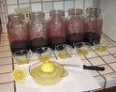
- Percolation involves maceration followed by slow flow of the extract through the percolator.
- Normally, percolation is not used as a continuous method b/c the sample is steeped in solvent in the percolator up to 24 h (for up to three times), then the extracted materials are collected and pooled.
- It has been observed that, after a triple- solvent extraction, the remaining marc does not contain valuable material.
- Percolation is more efficient than maceration b/c it is a continuous process in which the saturated solvent is constantly being displaced by fresh menstrum.
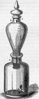
- Solubility and diffusion are involved in the extraction process.
- Usually done at room temperature but could also be coupled with heat (digestion).

AAdvantage:
- Simplicity
- Preserve thermolabile compounds

DDisadvantage:
- Consumes too much solvent
- Saturation is attained quickly.
- Continuous stirring (shaking) might help.
- Time taking process with the possibility of hydrolysis of compounds

Practical considerations;
- Mix plant material and solvent in a container and extraction is done in another container. Why?
- Put the plant material first and add solvent gradually.
- Very fine powders, resins, and powders that swell or give vicious eluent cannot be extracted by percolation.
- Particles of too large a size may produce a high elution rate precluding the necessary equilibrium for the dissolution of the metabolites, and the menstrum (solvent) would percolate unsaturated.

c. Soxhlet (continuous) extraction
- Components of soxhlet extraction set up

  - Heat source
  - Flask containing solvent
  - Extraction chamber
  - Condenser connected to a flowing water
  - Extraction thimble (made of filter paper)
- Outline of extraction process
  - Powdered plant material is packed in the thimble and the mouth of the thimble covered by piece of cotton.
  - The packed thimble is put in the extraction chamber and enough amount of volatile solvent is added to the flask.
  - After all the components are fitted appropriately, water is let to flow through the condenser and the heater is switched on.
  - The heated solvent starts to evaporate and the vapor passes through the large arm of the extraction chamber and reaches the condenser where it will condense.
  - The condensed solvent drips on the thimble and starts to accumulate in the extraction chamber, extracting the plant material in the process.
  - When the solvent reaches the level indicated by the dashed line (in figure B) it will drain through the small arm of the extraction chamber to flask carrying with it some extracted constituents of the plant.
  - The solvent now will be again evaporated by the heat and evaporates leaving behind the constituents it extracted in the first cycle. The evaporated solvent passes through the steps discussed above and with each cycle more and more plant constituents will be extracted.

AAdvantage:
  - Saves solvent
  - Quick method
  - Ease of changing solvent for the preparation of fractions
D Disadvantage:
  - Requires special apparatus
  - Not applicable for thermolabile plant constituents

  - No direct contact between plant material and heat source
d. Refluxing
- Similar to decoction except that there is a condenser
- It is a constant volume extraction method because there is no wastage of solvent.

Advantage:
      - Saves solvent
      - Quick method

Disadvantage:
- Not applicable for thermolabile plant constituents

III. Solvents used in extraction
- The choice of appropriate solvent depends mainly on the solubility and stability of the plant constituents of interest
  - Remember that "like dissolves like".
- The solvent should dissolve the plant constituent of interest, be easy to remove, be inert, nontoxic and not easily flammable.
- For intracellular plant constituents, 80% methanol is commonly used since it can penetrate through cell membrane. 80% methanol is also refered to as "universal solvent" since it dissolves a wide range of compounds including non-polar and polar.
- For extracellular plant constituents, chloroform (CHCl₃); (hepato & nephro toxic), dichloromethane (CH₂Cl₂), acetone (CH₃COCH₃), methanol (C₂H₅OH), hexane (C₆H₁₄), petroleum ether, hydroalcoholic solutions etc. could be used.
- Diethyl ether is toxic and flammable hence rarely used.
- Generally, extraction of a given plant material starts with nonpolar solvents preferably pet. ether, n-hexane or cyclohexane to remove fixed oils and fats followed by a series of more polar solvents to exhaustively extract the marc.
- After extraction, the solvent is removed by rotary evaporation at no more than 30 - 40 °C to preserve thermolabile constituents.
- Concentrated extracts should be stored in a refrigerator and a trace of toluene is added to prevent fungal growth.
Non-volatile solvent extraction
- This process is used for the preparation of the finest of perfume oils.
- For the extraction of the flowers with non-volatile solvents the enfleurage, the pneumatic and the maceration methods are used.
1. The Enfleurage method
- A mixture of melted beef tallow and lard is thickly smeared on both surfaces of each of the glass plates which are enclosed in wooden frames.
- Each glass plate is sprinkled with flowers to cover its top, under this condition each layer of the flowers will be enclosed between the two layers of fat (24 hours).
- The process is repeated and fresh flowers are used for the same plates. In case of Jasmine flowers, the entire enfleurage process lasts for 70 days.
- The flowers are then removed and the saturated fat is extracted with absolute alcohol
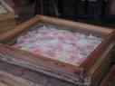
2. The Pneumatic method
- This process involves the passage of hot air through the flowers.
- The air laden suspended volatile oils is then passed through a spray of melted fat in which the volatile oil is absorbed, then triple extract are obtained the same way.
3. The maceration method
- The flowers are gently heated in melted fat (lard or fixed oil) in which they are incorporated and rotated until exhausted.
- They are then strained out, squeezed and the exuded fluid is returned to the fat and so on, until special concentration is reached.
- The fat saturated with oil is allowed to cool and the odorous principle is obtained by extraction with alcohol.
C. Supercritical solvent extraction
- Beyond its critical point, a fluid can have the density of a liquid and the viscosity of a gas, therefore it diffuses well through solids, and it is a good solvent.
- Although, in theory, several gases can be used, the focus is exclusively on carbon dioxide, and the reason for this becomes clear when considering its advantages:

  - It is a natural product,
  - Chemically inert,
  - Non-flammable,
- Perfectly non –toxic,
- Easy to eliminate completely,
Selective, readily available and
- Inexpensive

Distillation
i. Water distillation
- This method is applied to plant material that is dried and not subject to injury by boiling e.g.: turpentine oil is obtained in this manner. Crude turpentine oleoresin is introduced with water into the distilling chamber and boiled with water until both volatile matter and water, are condensed.
ii. Water and steam distillation
- This method is employed for plant materials, either dried or fresh that their volatile oil may be injured by boiling e.g. Cinnamon and Clove.
- Ground drug, is covered with water and steam is passed through the macerated mixture.
iii. Direct steam distillation
- This method is applicable for fresh drugs e.g.: peppermint. Crop is cut and taken directly to the distilling chambers. Drug is then suspended in wire basket or perforated trays or a similar container (grid). Steam is forced through the herb carrying the oil droplets to the condensing chamber.
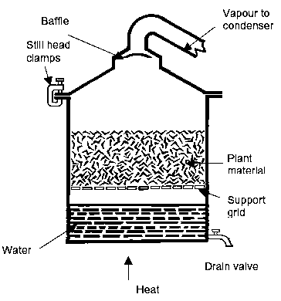

Mechanical extraction/expression
- The extrusion by application of pressure (squeezing out) is most satisfactory for the preparation of volatile oils and fixed oils.
- Volatile oils obtained by the expression methods maintain their fragrance while those obtained by distillation are inferior.
- Expression of volatile oils can be carried out by means of any of the following methods
    - The Sponge method
    - The Scarification method [Ecuelle a’piquer]
2.2 Factors affecting crude drug quality
  - The term quality when applied to crude drugs covers a number of aspects including:
- correct identity
- absence of adulterants and contaminates
- suitable levels of active principles (secondary metabolites)
  - These qualities of a crude drug may be influenced at any stage between the growing of the plant to the consumption point.
1 Plant growth
Medicinal plants may either be cultivated on farms or may be collected from wild sources.
Some cases: pharmacopoeias specify cultivated spp. Such as Fennel, ginger, cinnamon & opium
Other herbs: senna, tragacanth etc, may be collected from wild or cultivated species.
Disadvantages of wild plant collection:
- Sparse distribution e.g. Sceletium tortuosum
- Potentially difficult to transport herb to area of processing
- Difficult access (e.g. Forests, Mountains etc)
- Collector ignorance admixture of other plants, collection of undesired plant parts or stage of development or during an incorrect season loss of medicinal activity.
- Damage to natural environment Extinction of a spp.
Advantages of cultivated herbs
- Only desired spp are collected uniform quality.
- Collection, transport & access to processing facilities are improved.
- Better control of soil quality, pests & plant disease.
- Supply: Constant & Regular (Controlled)
- Herb collectors - trained
2. Genetics
- Genetic variants of the same species may yield different levels of the same active constituents.
- "Chemical races" have been identified in many medicinal plants
3. Growth conditions
A. Climate and weather
- These include: temperature, rainfall, hours of daylight, etc.
- Plants grown in different climatic conditions will be of different quality, and even those grown in the same area will vary in quality from year to year due to climatic conditions.
E.g. Datura stramonium: lower alkaloids in cloudy/rainy weather (winter).
E.g. Volatile oils are produced more readily in warmer weather, yet very hot days lead to a physical loss of oil.
  - Growing peppermint in shade rather than the sun.
Continuous rainfall: loss/leaching of water-soluble substances through leaves & roots: glycosides, tannins & flavonoids & some volatile oils.
E.g. peppermint:
  - Long day: menthone, menthol & menthofuran traces
  - Short day: menthofuran = main component
Other spp: produce more active constituents at night E.g. Nicotaina
B. Latitude/Altitude: mainly influences the climate
- Gentian: bitter constituents increase with altitude
- Thyme & Peppermint: constituents decrease with altitude
- Peanut & olive trees grown in the subtropics have a higher unsaturated fat content.
C. Soil: This include, soil pH, texture, and mineral content
4. Collection
- During collection the quality of crude drugs may be affected due a number of factors:
Correct identification of the plant:
  - The plant may accidentally or deliberately be replaced or contaminated with a different species.
Time of collection:
  - The content of active constituents of plants may show seasonal and diurnal variations (qualitatively and/or quantitatively).
  - Stage of maturity and age:
    - The value and content of active constituents of many drugs depends on the stage of maturity and age.
    - Conium fruits contain coniin when fruits are mature and unripe.
    - Santonica flowers are rich in santonin, when unexpanded, when it starts to open, the santonin content decreases.
    - Clove flower bud contain volatile oil but as the flower starts to mature, less volatile oil and more starch is produced.
  - Time of the year:
    - The plant may contain a substance in winter that is not present in summer, or its amount varies markedly e.g. Rhubarb contains no anthraquinone in winter, instead it contains anthranols, which in summer, are oxidized to anthraquinones.
    - Colchicum corm is free from bitterness and is devoid of the alkaloid colchicine in autumn, hence is used in Austria as a food, instead of potatoes. Bitterness starts to appear in spring and early summer when it is used as a drug.
  - Time of the day:
- Some drugs, like Digitalis, contain different amounts of active constituents in different times of the day. Being highest in the afternoon.
Method of collection:
    - Plants could be collected manually or by machinery
    - Collection may introduce unwanted foreign matters like soil in roots etc.
    - The cutting material could also affect quality.
5. Preparation of plant material
- Drying and concomitant process may influence quality
  - Slow drying may facilitate microbial growth and enzyme action.
  - Fast drying (excess heat) may lead to decomposition of secondary metabolites.
  - Sunlight may result in photoreactions.
6. Adulteration (sophistication)
- Adulteration is defined as the introduction of organic or inorganic material (other than that specified in the official descriptions of the drug) by human factors.
- Adulteration may be accidental or deliberate.
- Adulteration may occur as admixture of the drug with other material or as complete substitution of the drug by another substance.
- Adulteration whether accidental or deliberate can occur anywhere starting from the collection stage to the point of consumption.
- Products from disreputable companies or those without proper quality control facilities are highly liable to adulteration.
Types of adulteration and means of detecting them
a. Accidental adulteration
- This occurs as a part of the normal process of collection of the drug and its preparation for the market.
- Accidental adulteration may be tolerated as long as it is with the specified Pharmacopoeial limit (e.g. in BP usually 2% w/w).
- Accidental adulteration may comprise:
- Presence of inorganic matter e.g. soil, sand.
- Detected by high ash values, macroscopic and microscopic examination.
- Presence of parts of the plant other than the official part.
- These other organs may contain a low amount of active constituents or none at all or may contain toxic compounds.
- Detected by macro/ micro examinations
- Presence of other plants growing on or together with the drug plant and collected in the harvesting process.
  - Detected by macro/ micro examinations, chromatographic profile
    - The wrong plant collected mistakenly for the genuine one by unskilled collectors (misidentification)
  - Detected by macro/ micro examinations, chromatographic analysis, chemical tests
b. Deliberate adulteration
- Deliberate adulteration usually takes place when the drug in question is short supply and/or commands a high price.
- May be carried out in the form of admixture or substitution.
- The adulterant is usually a readily available cheaper, often worthless material.
- Common types of adulterants employed for deliberate adulteration:
  - Completely different plant with superficial resemblance to the authentic drug.
- Detected by macroscopical / microscopical examinations, chromatographic profile, chemical tests
- A species closely related to the official drug but with slightly different constituents or lower amounts of the active compounds.
- Detected by careful macro/ micro examinations, chromatographic profile, assay procedures
- The same species as the official drug but an inferior commercial variety with lower active compounds or slightly different constituents.
  - Detected by chromatographic profile, assay procedures
- The authentic species from which the active compounds have been extracted (exhausted material).
  - Detected by assay procedures
- Same as IV. but the buyers sample "fortified with a major component of the drug.
  - Detected by chromatographic profile
- Same as IV. but treated with some sort of masking agent to hide poor quality.
  - Detected with ash values, chromatographic profile, assay procedures
- Simulated worthless structures made to look like the authentic drug.
  - Detected by macro/ micro examination
- Heavy material to increase the bulk.
- Detected by macro/ microscopical examination, ash values
- Herbal products "fortified" with synthetic drugs known to have the effect for which the herbal remedy is taken.
- Detected by chromatographic profile
- When the plant material is powdered, adulteration is more difficult to detect by macroscopical examination.
- Common adulterants of powders are sawdust, ground nutshells, starch, chalk, sand and other minerals
7. Deterioration
- Deterioration is the name given to a decline in quality of a drug due to the influence of either living organisms or physicochemical factors.
- When insects or larger animals are involved, the drug is said to be infested.
- Deterioration of a drug may take place at any point after its collection, but the most likely stage are
  - during storage (under unsuitable conditions)
  - during transportation (in unsuitable packages etc.)
7.1 Common causes of deterioration
    - Physicochemical factors e.g. light, oxygen, water which promote chemical reactions either directly by activation of enzymes.
- Common chemical reactions leading to decomposition of active components of crude drugs are hydrolysis, polymerization and oxidation
- Detected by microscopical examination and assay
    - Biological factors: microbial contaminations, insects and rodents.

2.3. ISOLATION AND PURIFICATION OF ACTIVE CONSTITUENTS
- Active constituents may be isolated from extracts by classical methods or chromatography.
- The choice of separation method is dictated by
  - amount of sample
  - level of purity required
  - availability of facilities
  - economic factors
2.3. 1. Classical methods of separation
- Usually applied for large amount of samples
- Relatively economical
- Time taking
1. Precipitation
- Substances may be precipitated from solutions either by:
  - decreasing solubility: e.g. Gums are soluble in water and they are usually separated from other water soluble contaminates by gradually adding methanol which leads to their precipitation
  - chemical reactions: tannins are may be precipitated from solutions by adding soluble salts of lead (e.g. lead acetate).
  - Tannin + Pb²⁺ precipitate
- Either compounds of interest or contaminates can be precipitated.
2. Fractional distillation
- a mixture of volatile substances may be fractionated since its components may have different boiling points (range).
- Less volatile compounds are separated first (at lower part of the condenser and more volatile compounds are separated at latter stages
- becomes more and more difficult to separate compounds whose boiling points are very close.
3 Formation of chemical derivatives
- Separation may be effected by making use of reversible reactions which can alter certain property of a substance.
Examples:
  - When phenolic compounds which are organic soluble are treated with alkalis they form water-soluble phenolate salts. Phenolate salts can generate back the original phenolic compounds if treated with acids.
  - Oxide compounds which are organic soluble can be precipitated by phosphoric acid. The oxides can be generated from the precipitates by simply heating.
  - Alcohols or carboxylic acids (non-volatile) can be rendered volatile if converted to esters. The esters can be hydrolyzed to regenerate the alcohols or carboxylic acids.
4. Crystallization
- Crystallization differs from precipitation in that the product is a well-defined crystalline substance.
- Crystallization occurs in supersaturated solutions.
- Super saturation may be achieved by cooling, evaporation of solvent, by salting out, by adding a solvent in which the compound of interest is not soluble or by a combination of two or more of them.
- The rationale behind using crystallization for separation is that the condition at which a solution attains super saturation with respect to a given solute varies from one solute to another.
5. Sublimation
- Sublimation is when a substance in the solid phase passes directly into the vapor phase without going into the liquid phase. This happens because the vapor pressure of a substance generally goes up as temperature increases and the boiling point of a liquid happens when its vapor pressure is equal to the applied pressure. If this vapor can then be re-solidified it will separate compounds with low vapor pressures and high vapor pressures.
- This re-solidification is usually collected in crystal form on the outside of a glass tube with some sort of very cold liquid inside to attract and solidify the compound with a higher vapor pressure in a vacuumed atmosphere.
- This method is generally quick however it is not as selective as other methods of purification.
- Sublimation has been shown to be a rapid and effective technique for the isolation of amino acids from natural samples for enantiomeric analyses and a good substitute for conventional cation-exchange. Amino acids have appreciable vapor pressures above 150°C and will sublime under partial vacuum at elevated temperatures without any racemization or decomposition.
4. Centrifugation
- Centrifugation is a process that involves the use of the centrifugal force for the separation of mixtures, used in industry and in laboratory settings.
- More-dense components of the mixture migrate away from the axis of the centrifuge, while less-dense components of the mixture migrate towards the axis.
- Chemists and biologists may increase the effective gravitational force on a test tube so as to more rapidly and completely cause the precipitate ("pellet") to gather on the bottom of the tube.
The remaining solution is properly called the "supernate" or "supernatant liquid". The supernatant liquid is then either quickly decanted from the tube without disturbing the precipitate, or withdrawn with a Pasteur pipette.

2.3.2. Modern method/Chromatography

1. Introduction
- Chromatography (from Greek χρώμα: chroma, colour and γραφειν: "graphein" to write) is the collective term for a family of laboratory techniques for the separation of mixtures.
- It involves passing a mixture dissolved in a "mobile phase" through a stationary phase, which separates the analyte to be measured from other molecules in the mixture and allows it to be isolated.
- The key to the separation is the differing affinities among analyte, stationary phase, and mobile phase. Chromatography is used by scientists to:
- Analyze – examine a mixture, its components, and their relations to one another
- Identify – determine the identity of a mixture or components based on known components
- Purify – separate components in order to isolate one of interest for further study
- Quantify – determine the amount of the a mixture and/or the components present in the sample
Chromatography is a very special separation process for a multitude of reasons!
- First of all, it can separate complex mixtures with great precision.
- Even very similar components, such as proteins that may only vary by a single amino acid, can be separated with chromatography.
- Second, chromatography can be used to separate delicate products since the conditions under which it is performed are not typically severe.

2. HISTORY
- It was the Russian botanist Mikhail Semyonovich Tsvet who invented the first chromatography technique in 1900 during his research on chlorophyll. He used a liquid-adsorption column containing calcium carbonate to separate plant pigments.
- The method was described on December 30, 1901 at the 11th Congress of Naturalists and Doctors (XI съезд естествоиспытателей и врачей) in St. Petersburg.
- The first printed description was in 1903, in the Proceedings of the Warsaw Society of Naturalists, section of biology.
- He first used the term chromatography in print in 1906 in his two papers about chlorophyll in the German botanical journal, Berichte der Deutschen Botanischen Gesellschaft.
- In 1907 he demonstrated his chromatograph for the German Botanical Society. Interestingly, Mikhail's surname "Цвет" means "color" in Russian, so there is the possibility that his naming the procedure chromatography (literally "color writing") was a way that he could make sure that he, a commoner in Tsarist Russia, could be immortalized.
- In 1952 Archer John Porter Martin and Richard Laurence Millington Synge were awarded the Chemistry Nobel Prize for their invention of partition chromatography.
- Since then, the technology has advanced rapidly. Researchers found that the principles underlying Tsvet's chromatography could be applied in many different ways, giving rise to the different varieties of chromatography.

3. CLASSIFICATION
- Classification According to the Mechanism of Separation
Adsorption Chromatography
- Adsorption chromatography is probably one of the oldest types of chromatography around.
- The equilibration between the mobile (liquid or gas) and stationary phase (solid) accounts for the separation of different solutes.
- Components of a mixture with better affinity to the stationary phase (solutes with better polarity) will be adsorbed strongly; hence, their movement will be impaired greatly. On the other hand, components of the mixture with lesser affinity to the stationary phase (solutes with less polarity) will move with the mobile phase at relatively faster rates.
- A mobile phase for adsorption chromatography is expected to dissolve at least most of the components of a mixture and also needs to be capable of displacing adsorbed solute molecules if they are to move with it. But, most of the common solvents can not carry out these two tasks to applicable extents hence, mixtures of solvents commonly referred to as solvent systems are used.
- A solvent system is composed of both polar (major portion and used to dissolve and carry away solute molecules) and non-polar portion (minor portion and used to displace solute molecules). It is always normal phase chromatography.
- 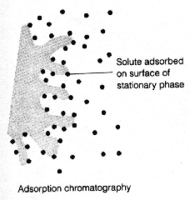
- Partition Chromatography
- This form of chromatography is based on a thin film formed on the surface of a solid support (usually silica gel and cellulose) by a liquid stationary phase.
- Solute equilibrates between the mobile phase and the stationary liquid and separation is due to difference in the partition coefficients of the various components of mixture.
- In most cases mixtures of compounds with known or predictable solubility are separated by this method. E.g. compounds belonging to a specific chemical class.
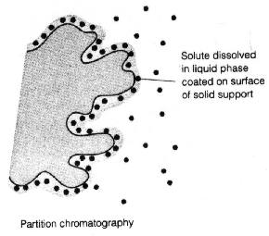
Ion Exchange Chromatography
- In this type of chromatography, the use of a resin (the stationary solid phase) is used to covalently attach anions or cation onto it.
- Solute ions of the opposite charge in the mobile liquid phase are attracted to the resin by electrostatic forces.
- Cation exchangers commonly have acidic functional groups such as: SO₃H, -PO₄H_{3,} -CO₂H, etc.
- Anion exchangers commonly have tertiary or quaternary ammonium groups: e.g. __N⁺ (CH₃) ₂ HCl⁻, __N⁺ (CH₃) ₃ Cl⁻
- The mobile phase is always an aqueous solution which is unusually buffered to a particular pH. It also contains some amount of the exchangeable ion.
- Common applications:
- Water treatment
- Ion recovery and removal from waste
- Separation of amino acids

General reaction that takes place on IEC

R⁻A⁺ + B⁺ R⁻A⁺ + B⁺

R⁺A⁻ + B⁻ R⁺A⁻ + B⁻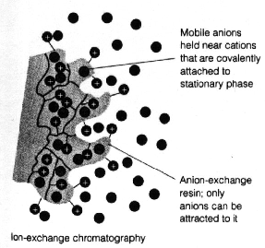

Molecular Exclusion Chromatography
- Also known as gel permeation or gel filtration, this type of chromatography lacks an attractive interaction between the stationary phase and solute.
- The liquid or gaseous phase passes through a porous gel, which separates the molecules according to its size.
- The pores are normally small and exclude the larger solute molecules, but allow smaller molecules to enter the gel, causing them to flow through a larger volume.
- This causes the larger molecules to pass through the column at a faster rate than the
- smaller ones.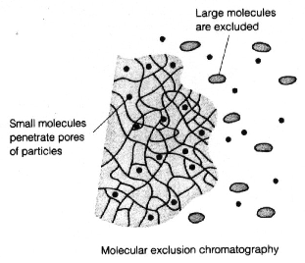

Affinity Chromatography
- This is the most selective type of chromatography employed.
- It utilizes the specific interaction between one kind of solute molecule and a second molecule that is immobilized on a stationary phase. For example,
- The immobilized molecule may be an antibody to some specific protein. When solute containing a mixture of proteins is passed by this molecule, only the specific protein is reacted to this antibody, binding it to the stationary phase. This protein is later extracted by changing the ionic strength or pH.
- 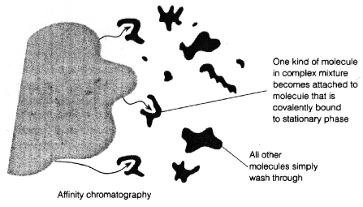
- Classification According to the Nature of the Mobile Phase
  - Liquid chromatography
  - Gas chromatography
  - Supercritical chromatography
- Classification According to the Polarity of the Stationary Phase
- Normal phase chromatography: the stationary phase is polar substance.
- Reversed phase chromatography: the stationary phase is non-polar substance.
- Classification According to the purpose of the chromatographic process
  - Preparative chromatography seeks to separate the components of a mixture for further use (and is thus a form of purification).
- Analytical chromatography normally operates with smaller amounts of material and seeks to measure the relative proportions of analytes in a mixture. The two are not mutually exclusive.
- Classification According to the Configuration of Instrument
  - Planar chromatography
TLC, PC…
  - Column chromatograpy
  - GC, HPLC, FCC,
- Planar Chromatography
Planar chromatography is a separation technique in which the stationary phase is present as or on a plane. The plane can be a paper, serving as such or impregnated by a substance as the stationary bed (paper chromatography) or a layer of solid particles spread on a support such as a glass plate (thin layer chromatography).

Thin Layer Chromatography

Thin layer chromatography (TLC) is a form of planar chromatography that involves:
- A stationary phase consisting of a thin layer of adsorbent material, usually silica gel, aluminium oxide, or cellulose immobilised onto a flat, inert carrier sheet.
- A liquid phase consisting of the solution to be separated is then dissolved in an appropriate solvent and is drawn up the plate via capillary action, separating the experimental solution based on the polarity of the components of the compound in question.
- Different compounds in the sample mixture travel different distances according to how strongly they interact with the adsorbent. This allows the calculation of an R_{f} value and can be compared to standard compounds to aid in the identification of an unknown substance.
Four purposes of performing TLC
- separate components in a mixture (preparative TLC)
- assess purity (how many spots are present)
- identify a substance (analytical TLC)
- assess compound polarity

Plate preparation
- TLC plates are made by mixing the adsorbent, such as silica gel, with a small amount of inert binder like calcium sulfate (gypsum) and water.
- This mixture is spread (pouring, dipping and spraying can also be done) as thick slurry on an unreactive carrier sheet, usually glass, thick aluminum foil, or plastic, and the resultant plate is dried and activated by heating in an oven for thirty minutes at 110 °C. Why???
- The thickness of the adsorbent layer is typically around 0.1–0.25 mm for analytical purposes and around 1–2 mm for preparative TLC. Why???
- To avoid absorption of moisture by the plates that the plates should be stored over desiccant.
Sample application
- A small spot of solution containing the sample is applied to a plate, about 1.5 cm from the base on 20 x 20 cm plate.
- Application could be in form of spots (for analytical chromatography) or in form of bands (for preparative work) by using capillary tube, a micropipette or a calibrated glass microsyring.
- Spots should not be closer than 1 cm center to center, should be 2-5 mm in diameter and 1-5 µg/µl solution concentrations are practicable.
Development
- The plate is dipped in to a suitable solvent or solvent system and placed in a sealed container.
- The tank should be the smallest possible and should be lined with filter paper to keep the atmosphere in the tank saturated with the solvent vapor.
- The solvent moves up the plate by capillary action and meets the sample mixture, which is dissolved and is carried up the plate by the solvent.
- Different compounds in the sample mixture travel at different rates owing to differences in solubility in the solvent, and owing to differences in their attraction to the stationary phase
- Separation of compounds is based on the competition of the solute and the mobile phase for binding places on the stationary phase.
- For instance, if normal phase silica gel is used as the stationary phase it can be considered polar.
- Given two compounds which differ in polarity, the most polar compound has a stronger interaction with the silica and is therefore more capable to dispel the mobile phase from the binding places. Consequently, the less polar compound moves higher up the plate (resulting in a higher Rf value).
- If the mobile phase is changed to a more polar solvent or mixture of solvents, it is more capable of dispelling solutes from the silica binding places and all compounds on the TLC plate will move higher up the plate.
- Practically this means that if you use a mixture of ethyl acetate and heptane as the mobile phase, adding more ethyl acetate results in higher R_{f} values for all compounds on the TLC plate. Changing the polarity of the mobile phase will not result in reversed order of running of the compounds on the TLC plate.
- If a reversed order of running of the compounds is desired, non-polar stationary phase should be used, such as C18-, C8- and phenyl-.functionalized silica.
- Mixtures of water or aqueous buffers and organic solvents are used as mobile phase.
- The appropriate solvent in context of thin layer chromatography will be one which differs from the stationary phase material in polarity. A suitable solvent should give R_{f} values between 0.3 and 0.7 for the sample components of analytical interest.
- If polar solvent is used to dissolve the sample and spot is applied over polar stationary phase TLC, the sample spot will grow radially due to capillary action, which is not advisable as one spot may mix with the other.
- Hence, to restrict the radial growth of sample-spot, the solvent used for dissolving samples in order to apply them on plates should be as non-polar or semi-polar as possible when the stationary phase is polar, and vice-versa.

Analysis
As the chemicals being separated may be colorless, several methods exist to visualize the spots:
- Physical detection methods
  - Visible light & UV
- Often a small amount of a fluorescent compound, usually Manganese-activated Zinc Silicate, is added to the adsorbent that allows the visualization of spots under a black light (UV₂₅₄).
  - The adsorbent layer will thus fluoresce light green by itself, but spots of analyte quench this fluorescence.
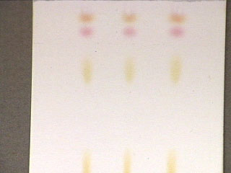 | 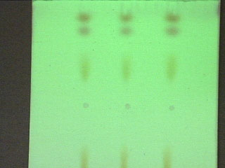
CCommercial TLC plate after development  in normal lighting. | Same TLC plate held under a UV lamp -  Note the appearance of additional spots.

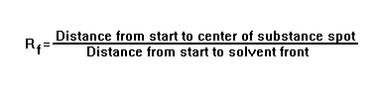The Rf value for each spot should be calculated. Rf stands for "ratio of fronts" and is characteristic for any given compound on the same stationary phase using the same mobile phase for development of the plates. Hence, known Rf values can be compared to those of unknown substances to aid in their identifications.

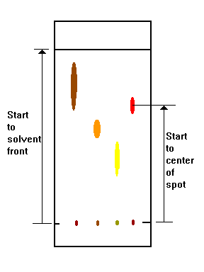

Rf values often depend on the temperature and the solvent used in the TLC experiment; the most effective way to identify a compound is to spot known substances next to unknown substances on the same plate.

In addition, the purity of a sample may be estimated from the chromatogram. An impure sample will often develop as two or more spots, while a pure sample will show only one spot.
- Chemical detection methods: spraying reagents/Chromogenic reagents.
  - General reagents e.g. H₂SO₄ for all organic compounds, I₂ for all unsaturated compounds etc.
  - Specific reagents e.g. Nihydrin for aminoacids, Dragendorff’s reagent for alkaloids, etc
    - Tests could result in reversible or irreversible reactions
Comparison of TLC with other chromatographic methods
- The process is similar to paper chromatography with the advantage of faster runs, better separations, better sensitivity (100 to1000 X) and the choice between different stationary and mobile phases and detection reagents (corrosive reagents can be used).
- The traditional open column liquid chromatography suffers poorly in comparison with thin layer method in that it is a fairly slow process which requires large amounts of packing material, eluant and sample.
Advantages of TLC
  - TLC sample require minimum sample preparation. Sensitivity is less than micogram/sample.
  - Simultaneous analysis of multiple standards and samples can be carried out under identical conditions.
  - Greater speed and better resolution.

ii. Paper Chromatography
- A form of planar chromatography where the stationary phase consists of a sheet of special grade paper, the cellulose paper fibers a matrix acts as the stationary phase and is able to retain a liquid stationary phase. Cellulose can adsorb up to 20% of its weight of water
- The dominant factor governing separation of mixtures on PC is ordinarily that of partition between two immiscible phases, one of which is usually water or some other relatively highly polar solvent

Performing PC:

The filter paper and the stationary phase

Highly purified cellulose

Separation and break of fibers dictate porosity and surface area

Surface structure, pH etc can be modified

Reversed phase pc can be used to separate lipophilic compounds after the paper is drawn through a solution of non-polar materials like: paraffin, vaseline, silicone….

Acidic groups may be introduced by chemical modification of the OH groups hence ion exchange chromatography for separation of cations.

E.g.
OH
OCH₂COOH

+ NaOH + chloroacetic acid

The mobile phase

Partially miscible with the stationary phase such as phenol, butanol and amyl alcohol

It is usually a binary mixture of incompletely miscible components.

The developer is made usually by shaking water with the organic solvent in a separatory funnel long enough to reach saturation of both phases and allowing them to separate completely.

The organic rich phase is used as the developer and the water rich phase is placed in a dish in the chromatographic chamber to facilitate saturation of the atmosphere.

Improved separation can be obtained by adjusting the acidity of the solvent with ammonia, acetic acid or by impregnating the paper with a buffer solution or formamide solution.

Application of samples

The sample should be compatible with the solvent and the paper

No corrosive nature

No inorganic salts to avoid streaking, discoloration and distortion

Samples are made in to solution and the solution is applied by using capillary tubes; spot size should be kept 5 mm

The solvent used to make solution of samples is dried off

Samples should not be immersed in the solvent; they should be applied few cms above the lower edge of the paper or the upper edge (in case of descending chromatography)

Excessive application of samples may cause streaking

The chromatographic paper is known us loaded filter paper once samples are applied onto it

Chromatographic tank: should be well closed and air-tight

Development

Ascending Development

Simple

The solvent or developer is allowed to creep upward up to a certain distance (usually two third of the length of the paper)

The developer is put at the bottom of the tank and the paper is immersed in it

Gravity counteracts the movement of the solvent

Descending Development

The solvent moves downwards along the paper up to a certain distance

Special apparatus is needed, container (through) for the mobile phase at the upper end of the tank and a glass rod onto which the paper is hanged

Detection of Spots

Physical detection methods

Visible light

UV

Chemical detection methods: spraying reagents or immersing the paper in the reagents

General reagents

Specific reagents

Tests could result in reversible or irreversible reactions

Identification of substances: substances are identified on the basis of their movement with the mobile phase. This is expressed as a function of Rf value.

Factors affecting Rf values

Chromatographic paper: kind, porosity, grade, length etc

Mobile phased used: pH, rate of movement

Temperature: since solubility is a function of T

Manner of development of chromatogram

Concentration of sample

The presence of other substances

Rf = Distance of spot / Distance the solvent has traveled (solvent front)

Rst= Distance of spot / Distance the standard = Rf spot / Rf standard

Applications of PC

Qualitative analysis

Quantitave analysis

Size of spot

Density of color of the spot

Spot area of standard vs. spot area of analyte (planimeter)

Cut the spots, dissolve and analyze

Advantages of PC

Simple

Many analytes can be analyzed simultaneously

Limitations

Slow

Only one technique is employed

Several spots from a single substance if:

The substance exists in ionic forms

The substance is isomeric

Oxidation occurs

There is overloading

b. Column chromatography
i. Simple column chromatography
Column chromatography is a chromatographic set up where the stationary phase is packed in a slender column; usually placed in a vertical position and the mobile phase is introduced through the upper opening. Ordinarily, solvent flow is gravity fed but sometimes could be assisted by external pressure.
- The classical preparative chromatography column is a glass tube with a diameter from 5 to 50 mm and a height of 50 cm to 1 m with a tap at the bottom.
- A slurry is prepared of the eluent with the stationary phase powder and then carefully poured into the column. Care must be taken to avoid air bubbles.
- A solution of the organic material is pipetted on top of the stationary phase.
- This layer is usually topped with a small layer of sand or with cotton or glass wool to protect the shape of the organic layer from the velocity of newly added eluent.
- Eluent is slowly passed through the column to advance the organic material. Often a spherical eluent reservoir or an eluent-filled and stoppered separating funnel is put on top of the column.
- The individual components are retained by the stationary phase differently and separate from each other while they are running at different speeds through the column with the eluent.
- At the end of the column they elute one at a time. During the entire chromatography process the eluent is collected in a series of fractions.
- The composition of the eluent flow can be monitored and each fraction is analyzed for dissolved compounds, e.g. by analytical chromatography, UV absorption, or fluorescence.
- Colored compounds (or fluorescent compounds with the aid of an UV lamp) can be seen through the glass wall as moving bands.
- is time taking and of lower efficiency.
- is usually applied to separate large quantities ( >1gm) and for large scale separation.(all modes of chromatography are possible)

A. Stationary phase (adsorbent)
- The stationary phase or adsorbent in column chromatography is a solid.
- The most common stationary phase for column chromatography is silica gel, followed by alumina. Cellulose powder has often been used in the past.
- Also possible are ion exchange chromatography, reversed-phase chromatography (RP), affinity chromatography or expanded bed adsorption (EBA). (all modes of chromatography are possible)
- The stationary phases are usually finely ground powders or gels and/or are microporous for an increased surface, though in EBA a fluidized bed is used.
- Ideal properties of adsorbent:
  - Of uniform, finely divided particles (↑ S. area)
  - White / colorless
  - Inert and stable to both the mp and sample
  - Insoluble in most organic solvents
  - High of selective
  - Flowable

B. Mobile phase (eluent)
- The mobile phase or eluent is either a pure solvent or a mixture of different solvents (not exceeding a mix. Of 3– solvents).
- Polar solvents are used to chromatograph polar compound do and vice verse.
- It is chosen so that the retention factor value of the compound of interest is roughly around 0.75 in order to minimize the time and the amount of eluent to run the chromatography.
- The eluent has also been chosen so that the different compounds can be separated effectively.
- The eluent is optimized in small scale pretests, often using thin layer chromatography (TLC) with the same stationary phase.
- A faster flow rate of the eluent minimizes the time required to run a column and thereby minimizes diffusion, resulting in a better separation, see Van Deemter's equation.
- A simple laboratory column runs by gravity flow. The flow rate of such a column can be increased by extending the fresh eluent filled column above the top of the stationary phase or decreased by the tap controls.
- Better flow rates can be achieved by using a pump or by using compressed gas (e.g. air, nitrogen, or argon) to push the solvent through the column (flash column chromatography).
- Ideal properties of mobile phase
  - Compatible with the whole chromatographic separation
  - Inert, non – explosive and not highly viscous
  - Neither highly volatile nor highly viscous
  - Of relatively low boiling point
  - Of low or minimal toxicity
  - Of low price /economic/.
C. Packing of the column
- May be packed Wet or Dry
a) Wet Packing
- The adsorbent is slurred with solvent (Preferably the first solvent to be used in the separation) and added to the column in portions.
- The packing is allowed to settle between additions.
- The suspending liquid is allowed to follow out slowly but the liquid level in the column is maintained above the packing at all times (to avoid drying)
- Conditioning is important (not < 24 hrs before applying the sample.
  - To ensure uniform packing
  - Exclude trapped air
  - Most commonly used
  - Results in a more homogenous packing
b) Dry Packing
- In this method the column packing is added in portions, with vibration or tamping between additions so as to give maximum packing density.
- This process is repeated until the column is adequately filled.
- The column is there thoroughly washed with the first solvent.
  - The wash displaces air, washout impurities and prepares the column in suitable condition for separation and elution.
  - Trapped are bubbles leads to poor separation and tailing.
    - Degassing using for example vacuum pump helps in this.
D. Sample loading (application)
- Several ways
- Dissolve the sample in the least volume of the 1st solvent (initial mp).
  - The sample is then delivered on the top of column bed using a long pipette.
  - The column outlet is then opened to allow the sample solution to sink to the surface of the surface of the column.
- Direct deposition (coating) of the sample on to some adsorbent to form a friable powder.
  - The powder is then slurred with a little of the initial mp at the top of the column bed.
- Use of paper discs impregnated (loaded) with the sample mixture.
- The dried discs are placed on the top of just – dry surface, covered with a very thin layer of the solid support and subsequently wetted with few drops of solvent.
- Column development modes
i. Development analysis
- Solutes are separated in to well–defined zones by a developer. Development is then stopped before the fastest running component comes out of the column.
- After drying, the chromatogram is then extruded out of the column where detected zones are separately dissected and extracted with a proper solvent for further analysis.
          - Elution analysis
- In this type liquid chromatogram, an eluant is added continuously, in an isocratic manner to wash down the solutes selectively.
- In such a mode, the eluant must be less strongly adsorbed than the solute.
- Problems: - Tailing – could also be due to
- by strong interaction between solute and sp than b/n solutes
- column overloading
- poor sample application /packing
- improper selection of mp
  - Incomplete recovery of the strongly retained adsorptive
          - Gradient elution analysis
The polarity of the mobile phase is increased slowly:
a. Step gradient: Δ in mp composition at predetermined interval.
b. Continuous gradient: Δ in mp composition is gradual and continuous.
Advantages:
- Tailing (trailing) of closely related substances is reduced
- Substances with widely different properties can be separated in a reasonable time, in a single operation.
iv. Displacement analysis
vi. Frontal analysis
F. Collection and Visualization of column fractions
  - Fraction could be collected based on fixed volumes or specified times.
  - Similar compounds are bulked together and subjected for further analysis.
  - Detecting of the separated bands could be done either in situ (on – column) or out of column
    - On – column detection
  - Used in case of colored compounds or those that fluoresce in UV light
  - Other alternative is to use color developing reagent where the chromatogram is carefully extruded and streaked with a chromogenic reagent
    - Out of column detection
  - Column fractions can be collected, the solvent evaporated and subjected to uv light or color reagents (TLC and PC)
Liquid scintillation counter is used for samples containing radio – active isotopes.
G. Factors affecting column efficiency and separation
- Column dimensions
  - as length width ratio ↑ -> column efficiency continually improves
Reasons:
  - Length and number of theoretical plates ↑
  - Uniform packing is obtained in narrower column
- Adsorbent
  - Particle size of SP:
    - as P. size ↓ the sorption equilibrium on the column increases and separation improved.
    - average particle diameter in open column chromatography covers a range from 10 - 2000μm
  - uniformity of packing of the column
-> Efficient separation if unif. Packing
  - Adsorbent activity
    - water deactivation
- Mobile phase /solvent/ * Percolates through the sp.
  - selection of the solvent
  - flow rate is inversely proportional to viscosity and solvents of low viscosity are useful in high efficiency separation.
  - Polar solvents are used to chromatograph polar compound do and vice verse.
  - Solvent/solvent system (not exceeding a mix. Of 3– solvents)
  - Solvents can be grouped in an increasing or decreasing order of elution strength
    - An eluotropic series is a listing of various compounds in order of eluting power for a given adsorbent. Such series are useful for determining necessary solvents needed for chromatography of chemical compounds.
  - Constancy of flow
  - The flow should be continuous.
  - Solvent flow rate
  - Uniform and low flow rate will result in a more satisfactory separation
- Concentration of Solute
  - At high conc., the solute band over shoots and moves more rapidly through the column “Bearding”
  - Sample to adsorbent ration of 1:30 to 1:50 should be used.
- Temperature
  - The chromatographic operation should be done at constant temperature, because temprature affects:
  - Distribution co-efficent of the components
  - Viscosity of the solvent -> flow rate
  - Adsorption is also ↓ed at higher temperature.
Limitations
  - Limited detection methods for separated fractions
  - Time taking
  - Quantitative analysis can’t be efficiently done
Application of CC in pharmacy
      - Separation and purification of d/t plant constituents in to individual components
Eg. Alkaloids of opium, cardiac glycosides of digitalis
      - Separation and purification of components of reaction mixtures in pharmaceutical Synthesis
      - Sample preparation for other sophisticated equipment eg. HPLC and GC
Eg. Use of sample preparation columns (SPC) based on solid phase extraction technique (SPE).

Separation
Isolation
Identification

Extraction
Crude Extract
Extract Fractions
Pure Compounds
Biomass
Active lead compounds
Determination of biological activity

2.4. Primary and secondary metabolites
All organisms need to transform and interconvert a vast number of organic compounds to enable them to live, grow, and reproduce. They need to provide themselves with energy in the form of ATP, and a supply of building blocks to construct their own tissues. An integrated network of enzyme mediated and carefully regulated chemical reactions is used for this purpose, collectively referred to as intermediary metabolism, and the pathways involved are termed metabolic pathways.
Some of the crucially important molecules of life are carbohydrates, proteins, fats, and nucleic acids. Apart from fats, these are polymeric materials. Organisms vary widely in their capacity to synthesize and transform chemicals. For instance, plants are very efficient at synthesizing organic compounds via photosynthesis from inorganic materials found in the environment. Other organisms such as animals and microorganisms rely on obtaining their raw materials in their diet, e.g. by consuming plants.

The pathways for generally modifying and synthesizing carbohydrates, proteins, fats, and nucleic acids are found to be essentially the same in all organisms, apart from minor variations. These processes demonstrate the fundamental unity of all living matter, and are collectively described as primary metabolism, with the compounds involved in the pathways being termed primary metabolites.
Thus degradation of carbohydrates and sugars generally proceeds via the well characterized pathways known as glycolysis and the Krebs/citric acid/ tricarboxylic acid cycle, which release energy from the organic compounds by oxidative reactions. Oxidation of fatty acids from fats by the sequence called β-oxidation also provides energy. Aerobic organisms are able to optimize these processes by adding on a further process, oxidative phosphorylation. This improves the efficiency of oxidation by incorporating a more general process applicable to the oxidation of a wide variety of substrates rather than having to provide specific processes for each individual substrate. Proteins taken in via the diet provide amino acids, but the proportions of each will almost certainly vary from the organism’s requirements.
Metabolic pathways are thus available to interconvert amino acids, or degrade those not required and thus provide a further source of energy. Most organisms can synthesize only a proportion of the amino acids they actually require for protein synthesis. Those structures not synthesized, so-called essential amino acids, must be obtained from external sources. Primary metabolic pathways synthesize, degrade, and generally interconvert compounds commonly encountered in all organisms.

An area of metabolism concerned with compounds which have a much more limited distribution in nature. Such compounds, called secondary metabolites, are found in only specific organisms, or groups of organisms, and are an expression of the individuality of species. Secondary metabolites are not necessarily produced under all conditions, and in the vast majority of cases the function of these compounds and their benefit to the organism is not yet known. Some are undoubtedly produced for easily appreciated reasons, e.g. as toxic materials providing defense against predators, as volatile attractants towards the same or other species, or as coloring agents to attract or warn other species, but it is logical to assume that all do play some vital role for the well-being of the producer. It is this area of secondary metabolism that provides most of the pharmacologically active natural products. It is thus fairly obvious that the human diet could be both unpalatable and remarkably dangerous if all plants, animals, and fungi produced the same range of compounds.
Some groups of natural products could be assigned to either division. Fatty acids and sugars provide good examples, in that most are best described as primary metabolites, whilst some representatives are extremely rare and found only in a handful of species. Hopefully, the blurring of the boundaries will not cause confusion; the subdivision into primary metabolism (≡ biochemistry) or secondary metabolism (≡ natural products chemistry) is merely a convenience and there is considerable overlap.

THE BUILDING BLOCKS
The building blocks for secondary metabolites are derived from primary metabolism. The number of building blocks needed is surprisingly few. By far the most important building blocks employed in the biosynthesis of secondary metabolites are derived from the intermediates acetyl coenzyme A (acetyl-CoA), shikimic acid, mevalonic acid, and 1-deoxyxylulose 5-phosphate.These are utilized respectively in the acetate, shikimate, mevalonate, and deoxyxylulose phosphate pathways, which form the basis of succeeding chapters. Acetyl-CoA is formed by oxidative decarboxylation of the glycolytic pathway product pyruvic acid. It is also produced by the β-oxidation of fatty acids, effectively reversing the process by which fatty acids are themselves synthesized from acetyl-CoA. Important secondary metabolites formed from the acetate pathway include phenols, prostaglandins, and macrolide antibiotics, together with various fatty acids and derivatives at the primary/secondary metabolism interface.
Shikimic acid is produced from a combination of phosphoenolpyruvate, a glycolytic pathway intermediate, and erythrose 4-phosphate from the pentose phosphate pathway. The reactions of the pentose phosphate cycle may be employed for the degradation of glucose, but they also feature in the synthesis of sugars by photosynthesis. The shikimate pathway leads to a variety of phenols, cinnamic acid derivatives, lignans, and alkaloids.
Mevalonic acid is itself formed from three molecules of acetyl-CoA, but the mevalonate pathway channels acetate into a different series of compounds than does the acetate pathway. Deoxyxylulose phosphate arises from a combination of two glycolytic pathway intermediates, namely pyruvic acid and glyceraldehyde 3-phosphate. The mevalonate and deoxyxylulose phosphate pathways are together responsible for the biosynthesis of a vast array of terpenoid and steroid metabolites. In addition to acetyl-CoA, shikimic acid, mevalonic acid, and deoxyxylulose phosphate, other building blocks based on amino acids are frequently employed in natural product synthesis. Peptides, proteins, alkaloids, and many antibiotics are derived from amino acids, and the origins of the most important amino acid components of these are briefly indicated in Figure 2.1. Intermediates from the glycolytic pathway and the Krebs cycle are used in constructing many of them, but the aromatic amino acids phenylalanine, tyrosine, and tryptophan are themselves products from the shikimate pathway.
The building blocks
Primary metabolism
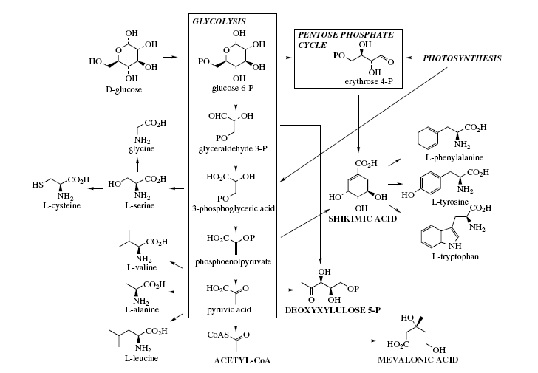
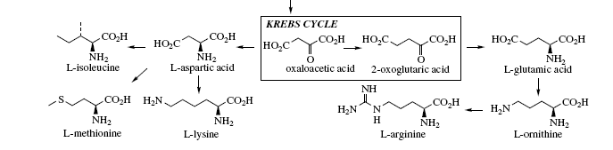
Figure 1.1

Ornithine,a non-protein amino acid, along with its homologue lysine, are important alkaloid precursors having their origins in Krebs cycle intermediates. Of special significance is the appreciation that secondary metabolites can be synthesized by combining several building blocks of the same type, or by using a mixture of different building blocks. This expands structural diversity, and consequently makes subdivisions based entirely on biosynthetic pathways rather more difficult. A typical natural product might be produced by combining elements from the acetate, shikimate, and deoxyxylulose phosphate pathways.
Many secondary metabolites also contain one or more sugar units in their structure, either simple primary metabolites such as glucose or ribose, or alternatively substantially modified and unusual sugars. To appreciate how a natural product is elaborated, it is of value to be able to dissect its structure into the basic building blocks from which it is made up, and to propose how these are mechanistically joined together. With a little experience and practice, this becomes a relatively simple process, and it allows the molecule to be rationalized, thus exposing logical relationships between apparently quite different structures. In this way, similarities become much more meaningful than differences, and an understanding of biosynthetic pathways allows rational connecting links to be established. This forms the basic approach in this book.

Relatively few building blocks are routinely employed, and the following list, though not comprehensive, includes those most frequently encountered in producing the carbon and nitrogen skeleton of a natural product. As we shall see, oxygen atoms can be introduced and removed by a variety of processes, and so are not considered in the initial analysis, except as a pointer to an acetate (see page 62) or shikimate (see page 123) origin. The structural features of these building blocks are shown in Figure 1.2.
• C1: The simplest of the building blocks is composed of a single carbon atom, usually in the form of a methyl group, and most frequently it is attached to oxygen or nitrogen, but occasionally to carbon. It is derived from the S –methyl of L-methionine. The methylenedioxy group (OCH₂O) is also an example of a C1 unit.
• C2: A two-carbon unit may be supplied by acetyl-CoA. This could be a simple acetyl group, as in an ester, but more frequently it forms part of a long alkyl chain (as in a fatty acid) or may be part of an aromatic system (e.g. phenols). Of particular relevance is that in the latter examples, acetyl-CoA is first converted into the more reactive malonyl-CoA before its incorporation.
• C5: The branched-chain C5 ‘isoprene’ unit is a feature of compounds formed from mevalonate or deoxyxylulose phosphate. Mevalonate itself is the product from three acetyl-CoA molecules, but only five of mevalonate’s six carbons are used, the carboxyl group being lost. The alternative precursor deoxyxylulose phosphate, a straight-chain sugar derivative, undergoes a skeletal rearrangement to form the branched chain isoprene unit.
• C6C3: This refers to a phenyl propyl unit and is obtained from the carbon skeleton of either L-phenylalanine or L-tyrosine, two of the shikimate-derived aromatic amino acids. This, of course, requires loss of the amino group. The C3 side-chain may be saturated or unsaturated, and may be oxygenated. Sometimes the side chain is cleaved, removing one or two carbons. Thus, C6C2 and C6C1 units represent modified shortened forms of the C6C3 system.
• C6C2N: Again, this building block is formed from either L-phenylalanine or L-tyrosine, L-tyrosine being by far the more common. In the elaboration of this unit, the carboxyl carbon of the amino acid is removed.
• indole.C2N: The third of the aromatic amino acids is L-tryptophan. This indole-containing system can undergo decarboxylation in a similar way to L-phenylalanine and L-tyrosine so providing the remainder of the skeleton as an indole.C2N unit.
• C4N: The C4N unit is usually found as a heterocyclic pyrrolidine system and is produced from the non-protein amino acid L-ornithine. In marked contrast to the C6C2N and indole.C2N units described above, ornithine supplies not its α-amino nitrogen, but the δ-amino nitrogen. The carboxylic acid function and the α-amino nitrogen are both lost.
• C5N: This is produced in exactly the same way as the C4N unit, but using L-lysine as precursor. The ε-amino nitrogen is retained, and the unit tends to be found as a piperidine ring system. These eight building blocks will form the basis of many of the natural product structures discussed in the following chapters. Simple examples of how compounds can be visualized as a combination of building blocks are shown in Figure 1.3. At this stage, it is inappropriate to justify why a particular combination of units is used, but this aspect should become clear as the pathways are described.
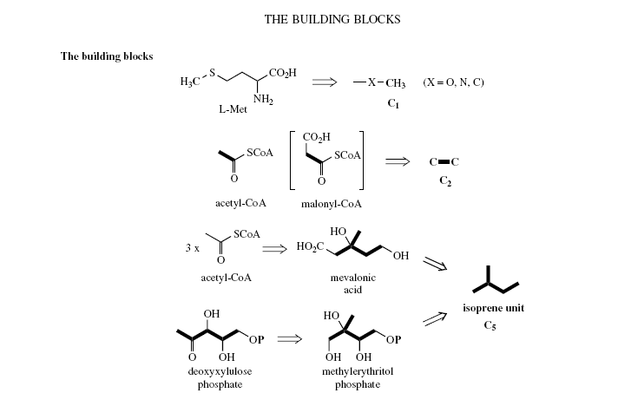
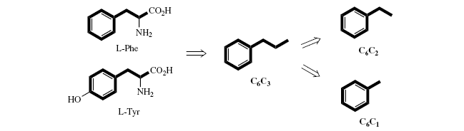
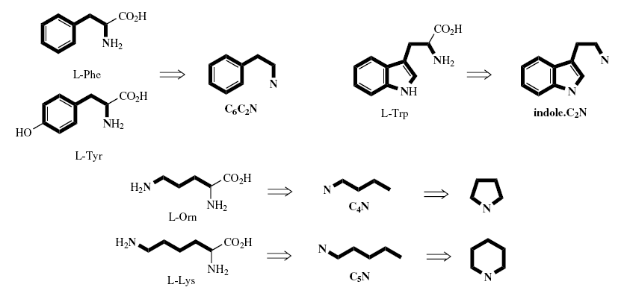

Figure 1.2
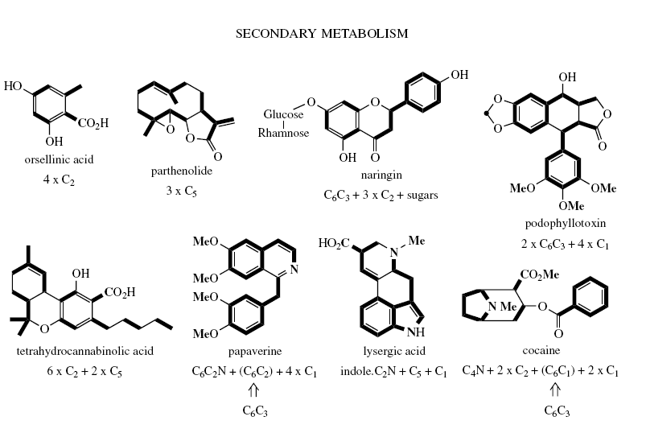
Figure 1.3
A word of warning is also necessary. Some natural products have been produced by processes in which a fundamental rearrangement of the carbon skeleton has occurred. This is especially common with structures derived from isoprene units, and it obviously disguises some of the original building blocks from immediate recognition. The same is true if one or more carbon atoms are removed by oxidation reaction.

Glycosides
Many plant secondary metabolites in nature occur as glycosides. Glycosides are derived by post modification of the secondary metabolites catalyzed by plant enzymes, glycosyltransferases. They are stored and transported in plant tissues as well as play significant roles in plants. Some of the roles are signaling, regulating growth & development and inhibit the growth of other plants. They also defend plants from pathogens and herbivores. Their production is usually governed by environmental conditions. Glycosides are comprised of two chemically and functionally independent parts; the aglycone (genin) and the glycine (saccharide) parts.
In a glycoside, the saccharide part is linked to the aglycone portion by a glycosidic bond. The glycosidic bond is mostly unstable and susceptible to hydrolysis (by diluted acids or by enzymes). Accordingly, the types of glycosidic linkages are classified as:
- O-glycosides
- C-glycosides
- S-glycosides
- N-glycosides

